**EEEN 561**

**MIDTERM PROJECT REPORT**

**Group Members:**

1. Ömer Sezer / 114202056
2. İlhan Can / 115202076
3. Furkan Ayşavkı / 115202028

**Project Description:**

In our project, we designed a PCB that is perfect fit for our graduation project which named as Smart Dust Embedded System. This PCB has exact dimensions to enable us mount every module/microcontroller with ease. As we used three different modules/sensors, we included headers and named them accordingly. We also have 4 mounting holes for easier mounting.

**Schematic**

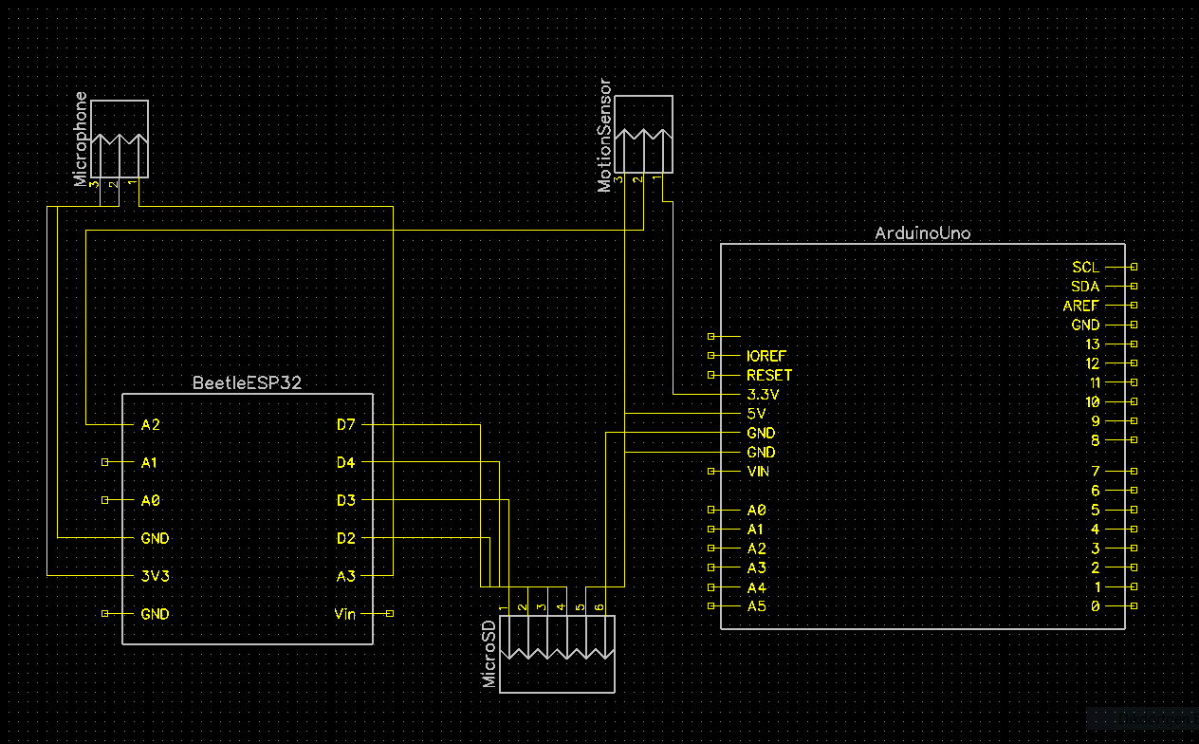

**Fig. 1.** Schematic Capture

**Bill of Materials**

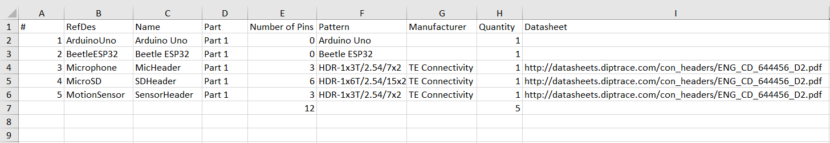

**Fig. 2.** Bill of Materials

**PCB Top Layer View**

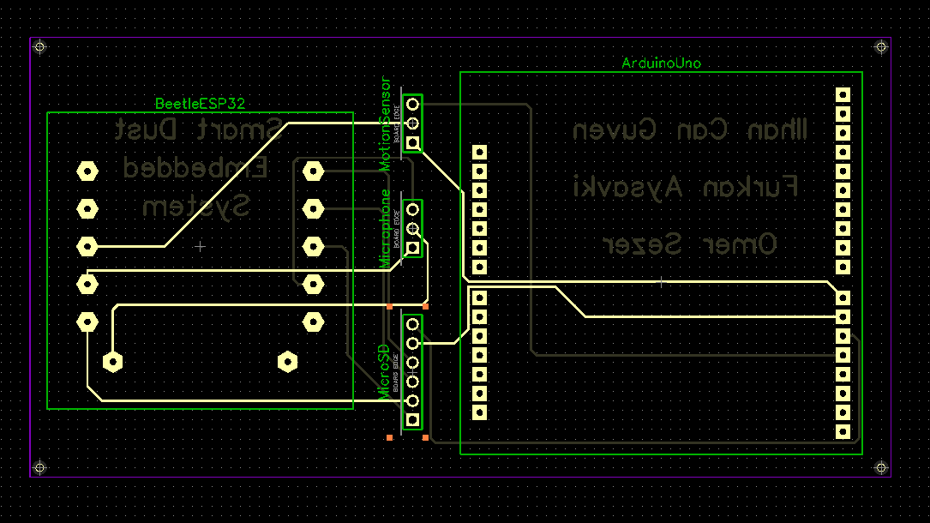

**Fig. 3.** PCB Top Layer View

**PCB Bottom Layer View**

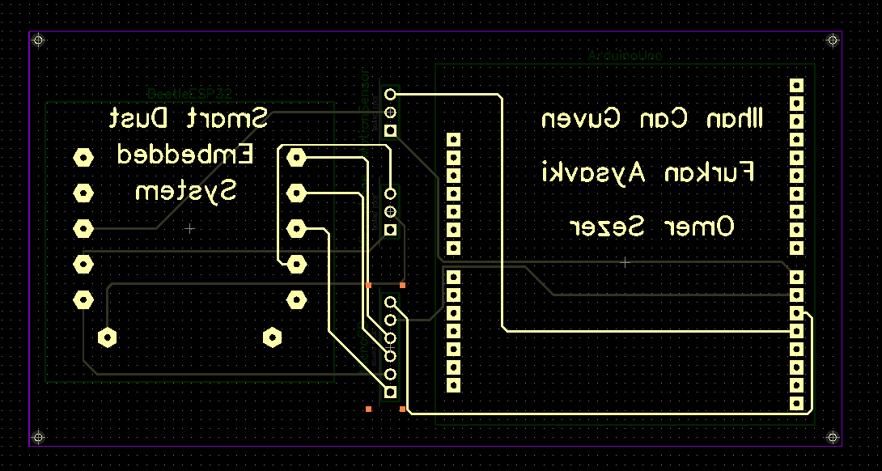

**Fig. 4**. PCB Bottom Layer View